The way this function works is it is separated into two parts. First of all it goes through every force which when talking about here is both the force and the angle of which it acts like a vector. It then calculates how much of its force applies to E and to N which are the things which will be passed to the next function. Once all of the forces have been acted on N and E it moves to the next section.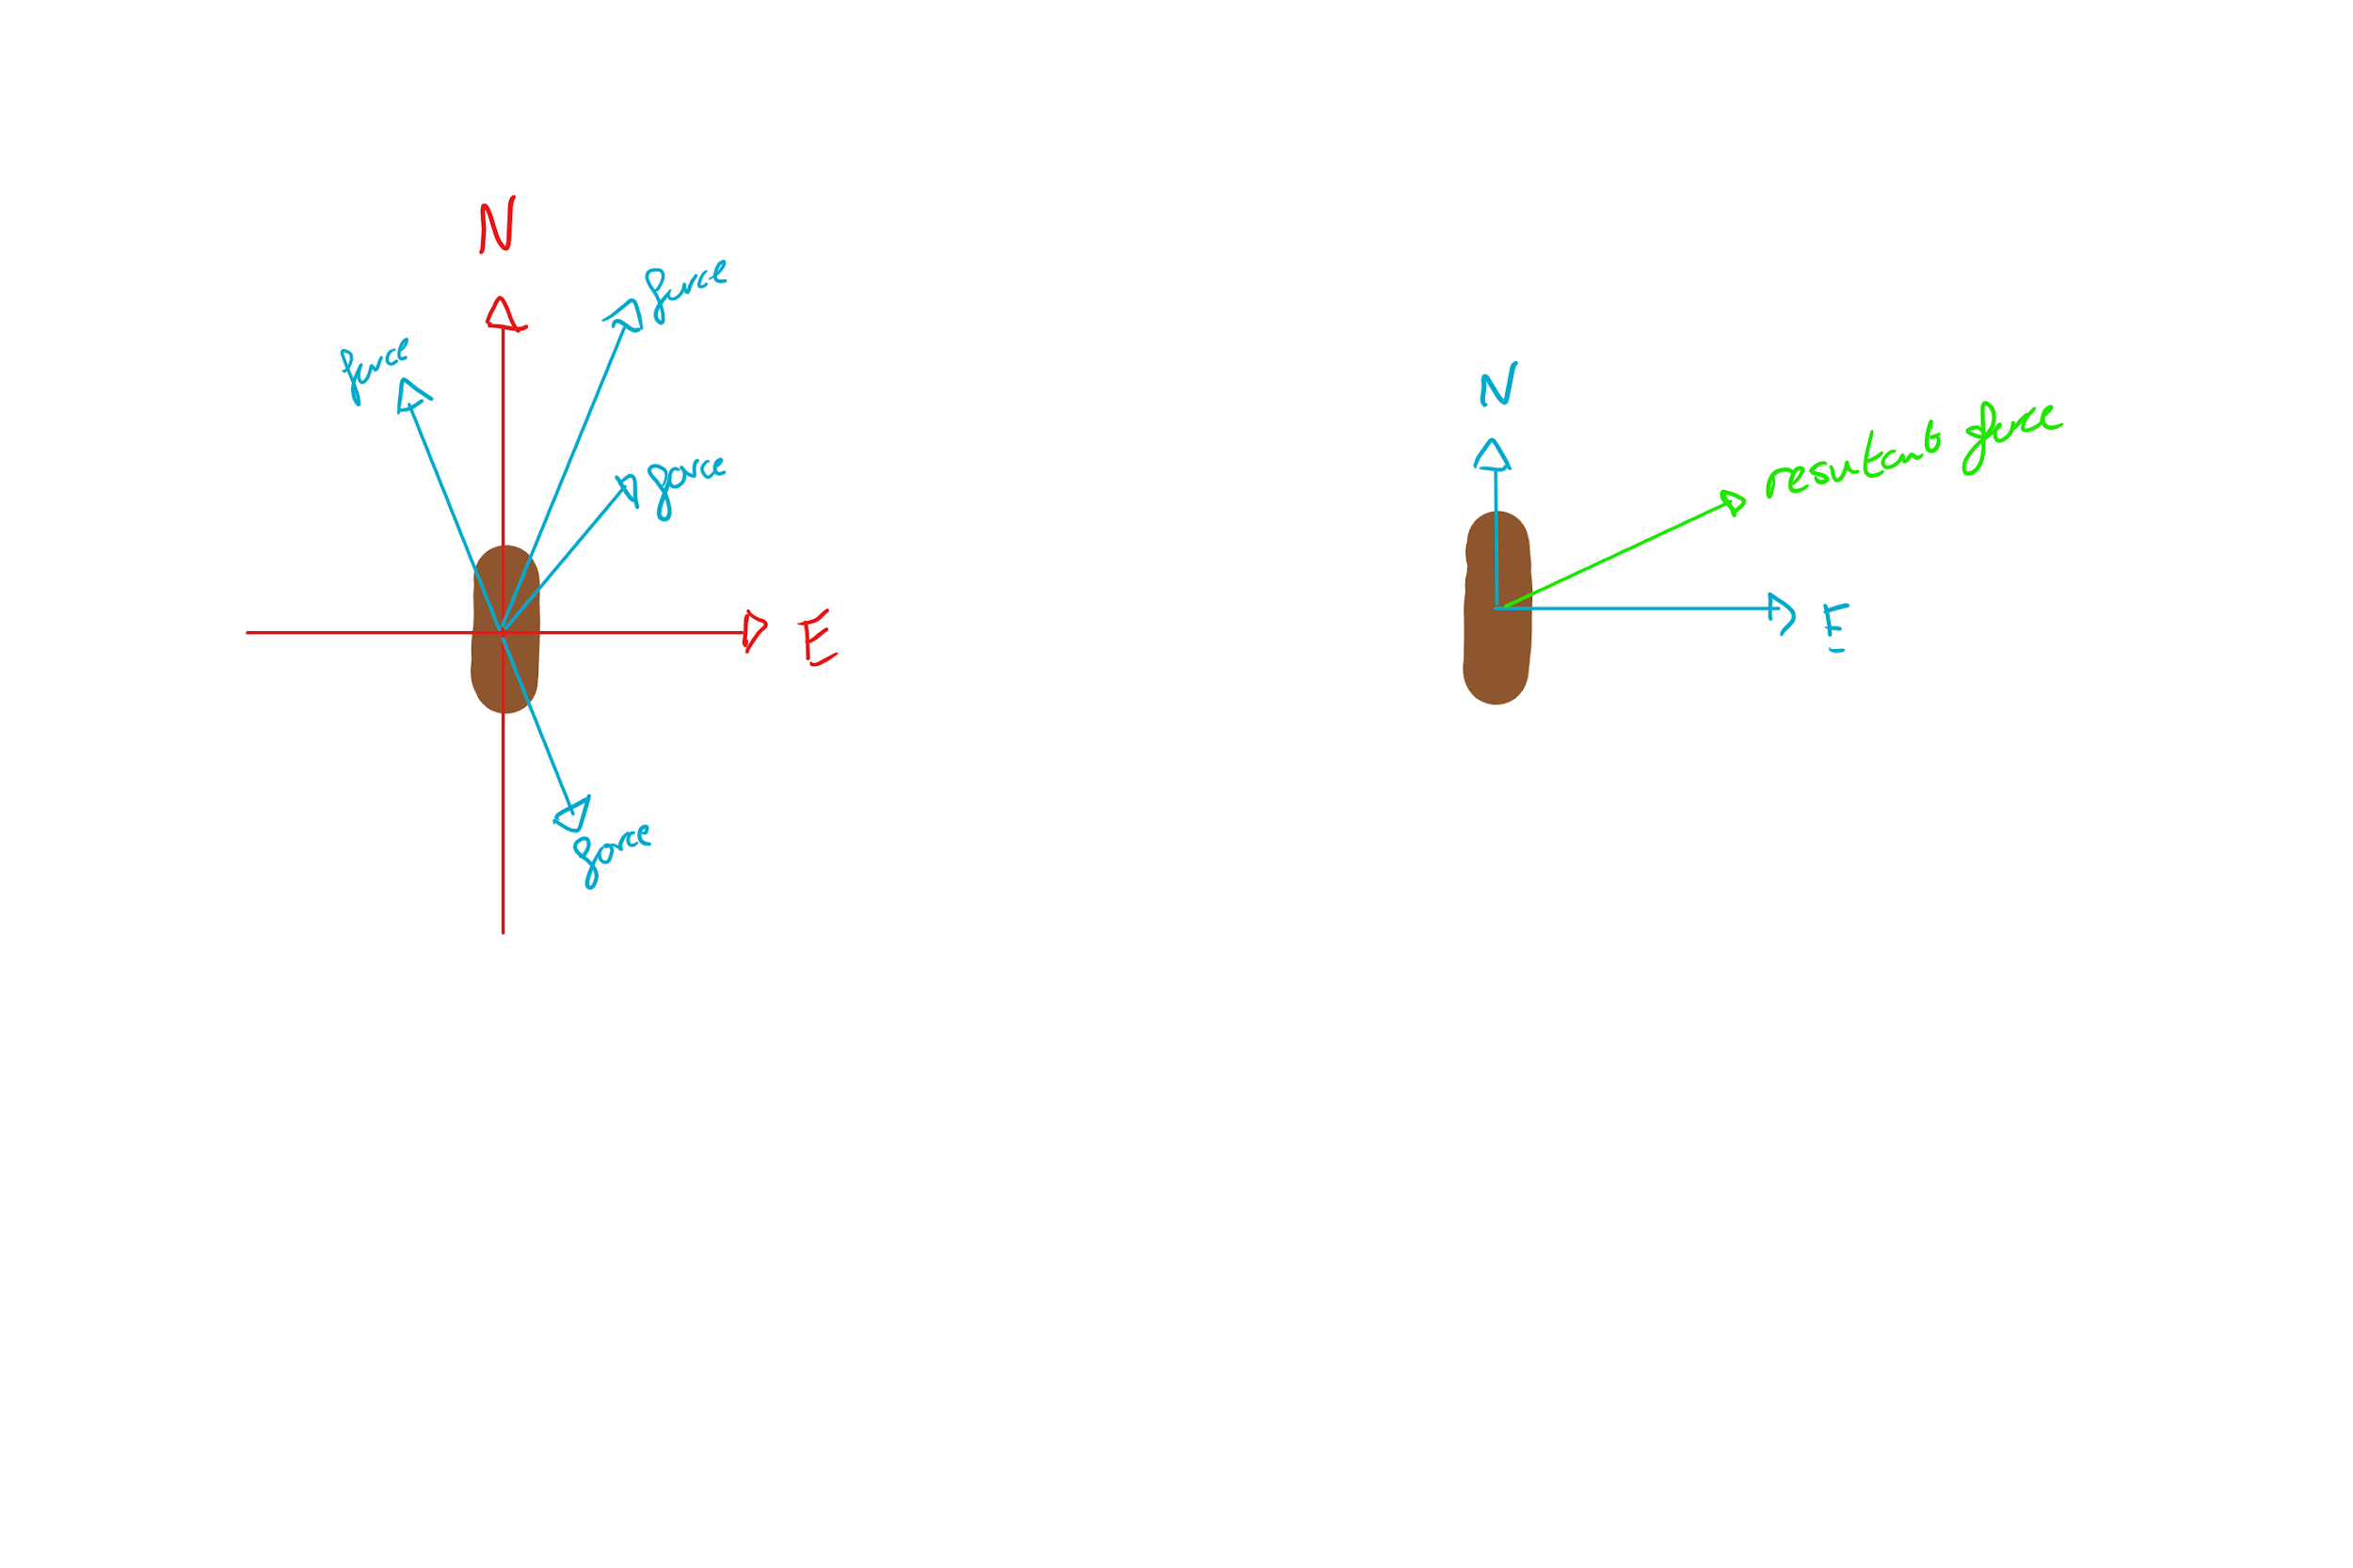

We now class N and E being the only forces on the object. We then calculate the resultant force the same sort of way we did the N and E but this time its how much it affects the resultant.

The forces talked about here aren’t usually actual forces applied to the boat but are usually the AI’s way of knowing which way it wants to go towards e.g. how much the AI wants to go that direction.